Database Design
7/12/2026
(Seth Hopkins)
Overview
I chose MySQL for my database to persist any data I need to keep. I chose it because it is a structured database with well defined entities for my user profile and ingredients. I also plan to host the website on AWS and they have a free tier for MySQL versus using SQL Server. Using MySQL allows it to be a highly scalable project and easily integrates into my preferred .NET framework. I will also be accessing data through the Spoonacular API to get recipes, and ingredients information. Their respective id’s will be stored in my persistent database for reference by the user. Caching data from the API will be one of the first additions I make to my database to improve performance after completing the MVP.

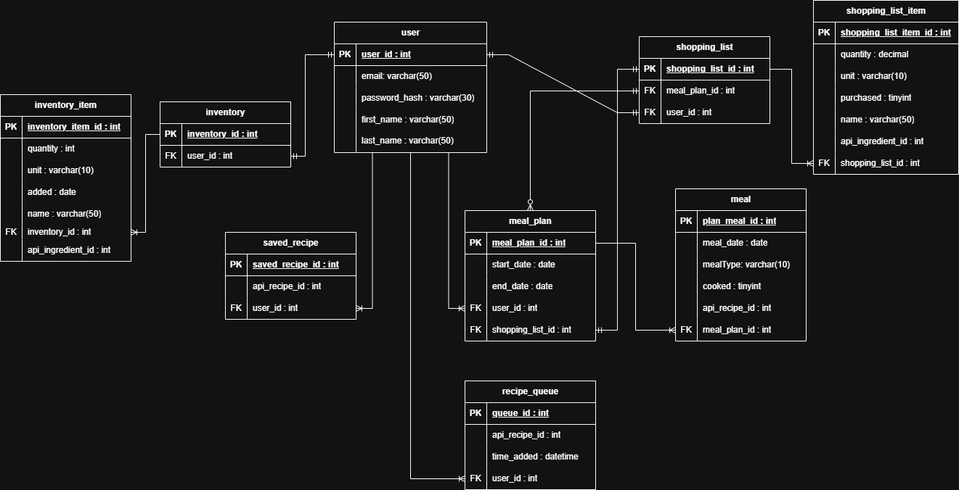

Entity Details
User
The user table will store information for each signed in user of the application. Keeping a hashed password and email for authentication. The user id will be used as a foreign key in other databases for user specific information like meal plans, shopping lists, and saved recipes.
Inventory
The inventory table will keep data for each user to reference their current inventory items for recipes and shopping list creation.
Inventory item
The inventory items table contains a detailed account of the foods available including an API ingredient id to be called for more information and a added date for aged food priority.
Saved Recipe
This table will allow users to store API recipes to be used again in later meal plans.
Meal Plan
This table has attributes for the start and end date of a week for a shopping list to reference when generating the list for the meals selected for the week.
Meal
This table contains detailed information for the meals selected for a meal plan id and the cooked status attribute to know the ingredients have been pulled from the inventory.
Shopping List
This table holds information about the users current shopping list where it can reference none or many meal plans based on what the user has selected.
Shopping List Item
This table contains the details of a shopping list id such as the ingredients and quantity to be purchased.
Recipe Queue
This table contains the recipes selected by the user to be held in queue till the user selects to what days they will be assigned in the meal plan. Thus, the user will be able to work on meal planning in stages.

